Names: Ayanda
Tech Bro
: Sokhohlo
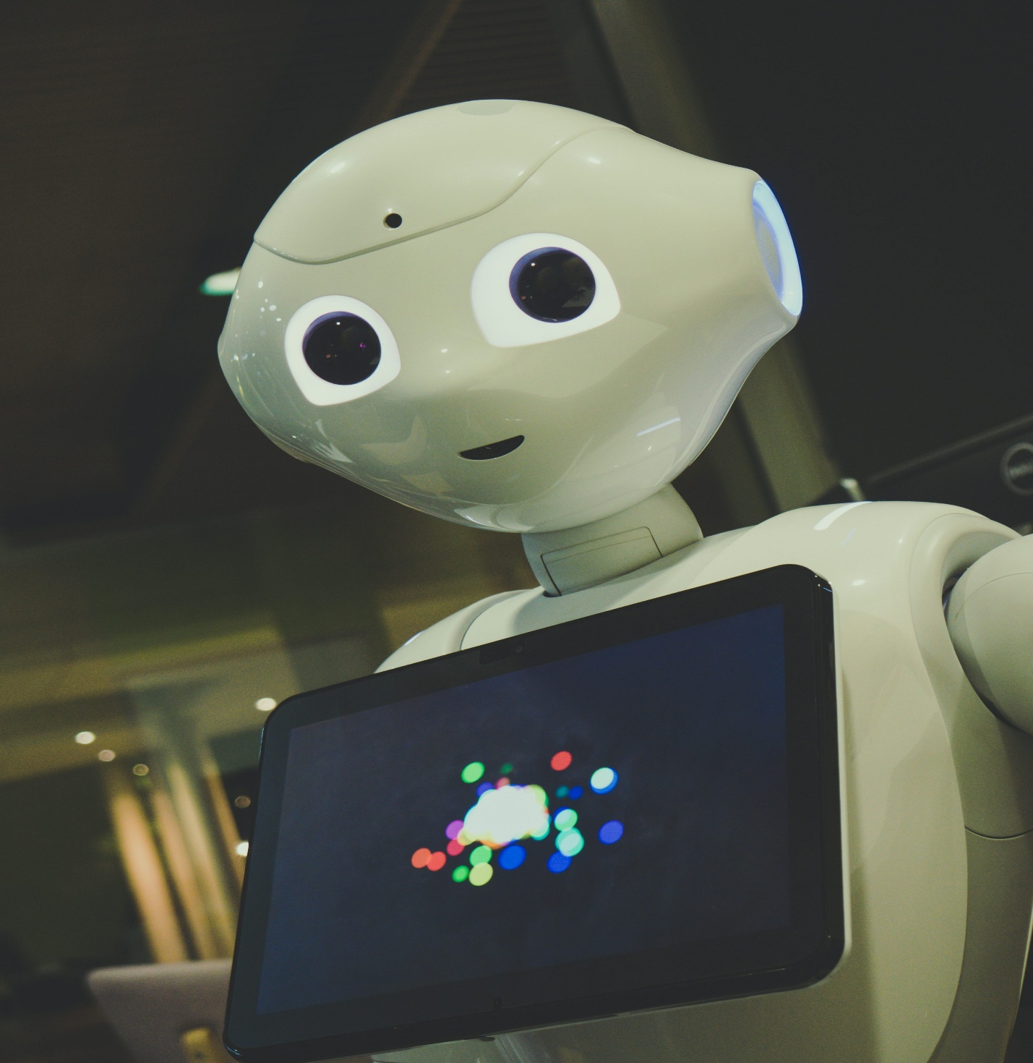
Topic: AI Powered Career Navigation for South African Youth

Contents
Problem Statement 3
Objective 4
Our Solution: A Personal Guide for Your Future 5
Expected Impact 6
Alignment with National Goals 6
Poster 7

Problem Statement
Imagine a young person in South Africa today. They have done everything they were told would lead to a better future. They have studied hard, passed their exams, and maybe even earned a degree. They are full of potential, ambition, and the desire to build a life for themselves.
But when they step out into the world, they hit a wall. They send out countless applications and face constant, deafening silence. Statistics are no longer just numbers; they become their reality. They are one of the over 60% of young South Africans who are ready to work but cannot find a job.
Why is this happening? The system is failing them.
- The "Wrong Skills" Trap: The world of work is changing at lightning speed, but what they learned in school often feels disconnected from what employers actually need. They are prepared for the jobs of yesterday, not the digital economy of today.
- Navigating in the Dark: Choosing a career path is one of the most important decisions of their life, but they are forced to make it with little guidance. Career counseling, if it exists at all, is often generic and outdated. It does not answer the crucial question: "What is the right path for me?"
- The One-Size-Fits-All Approach: A standard test or a brief chat cannot capture their unique talents, passions, and circumstances. A young person in a rural area faces a completely different set of opportunities and barriers than one in a major city, yet the advice is often the same.
- A Moving Target: Just as they think they understand the job market, it transforms again. New roles emerge, and old ones disappear, leaving them feeling perpetually behind.
This is not just a problem of unemployment; it is a crisis of wasted potential. It is the dreams deferred, the talent overlooked, and the frustration of a generation that is ready to contribute but is left without a map or a compass to find their way.
The challenge is: How do we replace the dead end with a pathway? How do we turn this generation's potential into its greatest asset?

Objective
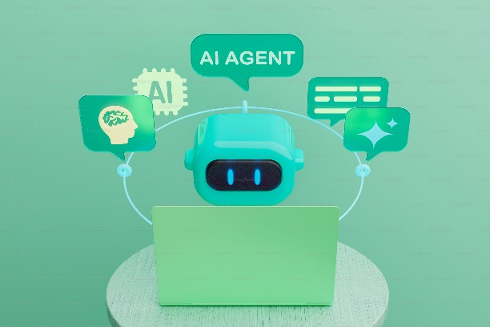
- To design an AI-powered web platform that uses machine learning, NLP, and real time data to guide South African youth toward personalized, actionable career pathways.

We are building more than a platform; we are building a personal guide for every young South African standing at the crossroads of their future.
Imagine a tool that listens to your dreams, understands your unique story, your strengths, your passions, your circumstances and then helps you map a route to a career that doesn't just pay the bills, but feels like it was made for you.
This is not a static database or a generic quiz. It is an intelligent companion that:
- Truly Gets You: By having a conversation with our AI, you can explore your interests in your own words. It understands what excites you, not just which boxes you tick.
- It Sees the Real World: It analyzes the live job market, identifying which roles are in demand and what skills you need to get them, cutting through the noise and focusing on real opportunities.
- Charts Your Unique Course: It does not just give you a job title. It provides a personalized, step-by-step pathway recommending specific courses, local training programs, and entry-level positions tailored for you.
- Grows With You: As the world of work changes, so does your guide. It continuously updates its knowledge to ensure your path remains relevant and achievable.

Our Solution: A Personal Guide for Your Future
For every young South African standing at the crossroads of their future, we are building more than a platform we are building a personal guide. This will be a friendly, accessible AI companion that feels like a conversation with a trusted mentor, always in your corner and available on any device.
Imagine a tool that will listen to your dreams and understand your unique story ,your strengths, your passions, your circumstances. It will then help you map a route to a career that does not just pay the bills but feels like it was made for you.
This will not be a static database or a generic quiz. It will be an intelligent partner on your journey, designed to:
- Truly Get You: Through natural conversation, you will explore your interests in your own words. Our AI will understand what excites you, moving beyond checkboxes to grasp your potential.
- See the Real World: The system will analyze live job market data to identify which roles are in demand and what skills you need to get them. It will cut through the noise and focus on tangible, local opportunities.
- Chart Your Unique Course: You will not just receive a job title. You will get a personalized, step-by-step pathway that recommends specific courses, local training programs, and entry-level positions tailored specifically for you.
- Grow With You: As the world of work changes, your guide will evolve. It will continuously learn and update its knowledge to ensure the path ahead remains relevant, dynamic, and achievable.
We are creating a future where the question, "What am I going to do with my life?" is met with a clear, confident, and personalized answer. This is how we will turn potential into purpose.

Expected Impact
- Unlock Potential, One Person at a Time: We'll move young people from feeling lost to feeling empowered, giving them a clear, personal map to careers where they can truly thrive.
- Bridge the Gap Between Learning and Earning: By using smart AI, we will directly connect a user's skills and passions with real market needs, ensuring their education leads to real opportunity.
- Guidance in Your Pocket: No office needed. This tool will work on any phone, bringing essential career guidance directly to young people in rural and underserved areas.
- Shape a Smarter Future: The insights we gather will paint a clear picture of youth potential and market needs, helping leaders in government and education make better decisions for everyone.

Alignment with National Goals
- 🇿🇦 For South Africa's Future: We are actively supporting the national NDP 2030 vision by equipping our youth with the tools they need to become drivers of an inclusive and thriving economy.
- For Quality Education: We are championing the UN Global Goal for Quality Education (SDG 4) by transforming career guidance from a one-time event into a continuous, personalized learning journey.
- For Economic Dignity: We are directly contributing to UN Global Goal for Decent Work (SDG 8) by creating a clear bridge for young people to find not just any job, but meaningful and sustainable work.
- For Digital Inclusion: We are putting digital inclusion into practice by using simple, accessible technology to ensure no young person is left behind in the journey from education to employment.

Sponsor Acknowledgment
This project is proudly supported by Amdocs, a global leader in digital transformation, cloud solutions, and AI-driven innovation. Amdocs empowers the world’s leading communications and media companies through intelligent technologies that enhance human connection.
Their commitment to digital inclusion, youth empowerment, and technology for social good aligns perfectly with our mission to guide South African youth toward meaningful and future-ready careers.

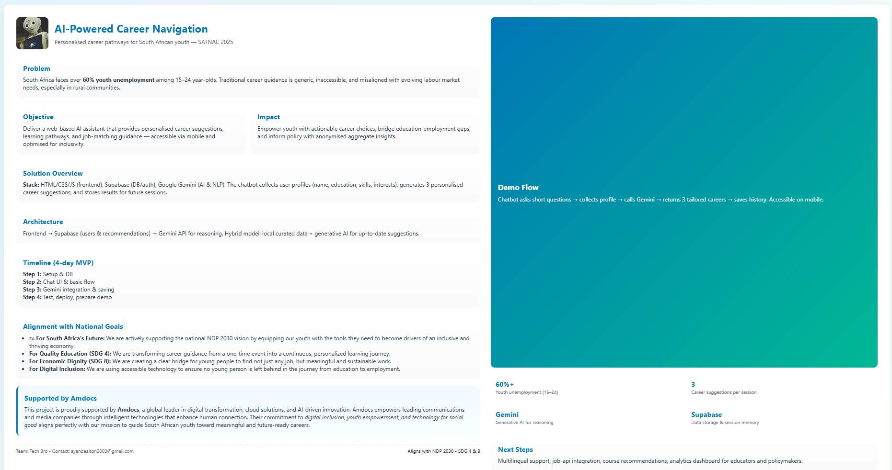
Poster

